- Configure Development Server and Content Store:
- Create following directories:
- C:\ ML-Forest
- C:\ Website
- Install marklogic server.
- Start marklogic server

  - Access MarkLogic Admin Site
To perform the tasks below:
- Go to: Start > Program Files > MarkLogic Server > Admin MarkLogic Server
- Enter your main username and password

  - Create "admin" User
If your main administrator user is not already called "admin", you need to create a new user called "admin" that has full administrator rights. To do this, use the Admin site:
- Go to: Configure > Security > Users
- Click on the "Create" tab
- Enter "admin" in the username field
- Enter a password in the password field and repeat it (say- “admin “ ,”admin”)
- Select the "admin" role
- Click "ok"
This login will be used to gain administration-level access to the TR application.

  - Create Forest and Database
To create the forest (data store):
- Go to: Configure > Forests
- Click on "Create" tab
- Enter “ML-Forest" in the forest name field
- Enter the directory path where you want to store forest in the “data directory” field. (E.g: C:\ ML-Forest)
- Click "ok"
- Go to: Configure > Databases
- Click on "Create" tab
- Enter "ML-Database" in the database name field
- Click "ok"
- Go to: Configure > Databases >ML-Database > Forests
- click on the " ML-Forest " check box
- click on "ok"
- Now Marklogic Server is ready for content storage.

Configuring XDBC
- Go to: Configure > Groups > Default > App Servers
- Click on "Create XDBC" tab
- Enter Name as ML-Xdbc
- Root as ” /”
- Port as 7777`
- Module as “filesystem”
- DatabaseName: ML-Database
  - Create HTTP Server - ML-Http
To create the web server that will host the TR Rest-Api:
- Go to: Configure > Groups > Default > App Servers
- Click on "Create HTTP" tab
- Enter " ML-Http" in the server name field
- Enter “C:\ Website" in the root field
- Enter "7778" (or other available port number) in the port field
- Select "(file system)" from the modules drop-down list
- Select "ML-Database" in the database drop-down list
- Select "basic" in the authentication drop-down list
- Select "nobody " for the default user
- Click "ok"

Configuring WebDAV
- go to: Configure > Groups > Default > App Servers
- click on "Create WebDAV" tab
- Enter Server Name as ML-WebDav
- Enter Root as “/”
- Put Port as 7779.
- Database as ML-Database
- Authentication as “basic”
- Click OK.

Integrating Marklogic with Oxygen
Note- For integration, oxygen license must be of Enterprise Edition.
    - Place xcc.jar file in the “C:\Program Files\MarkLogic\Apps\appbuilder\lib” folder.
    - Go to oxygen editor→Options→ Preferences→ Data Source
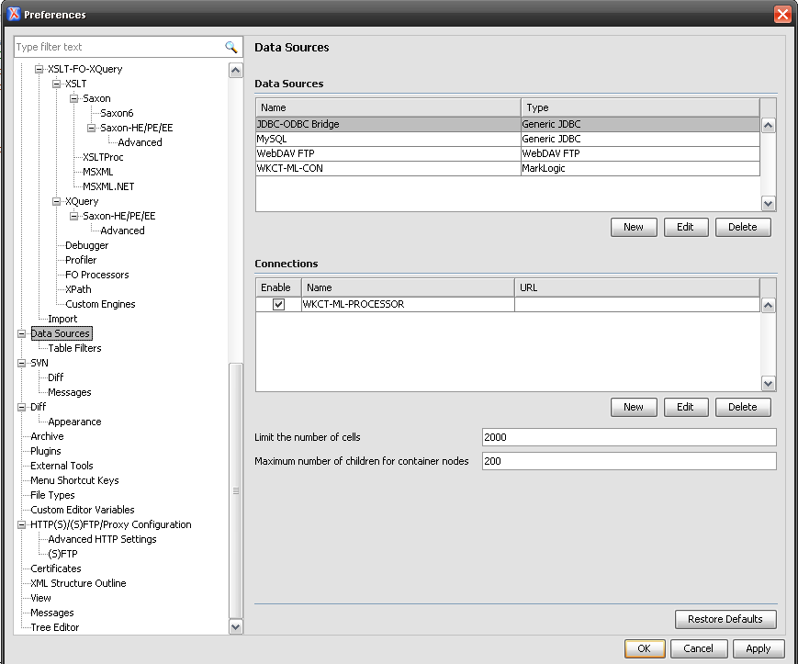
    - On the right side of the window create new data source and new connection as given below.
    - For new Data source click on new. On clicking it a new window will open.
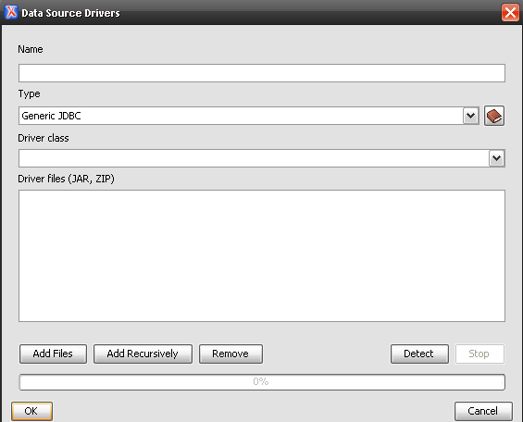

    - Write Name of datasource as “MarkLogic-Conn”.

    - Select Type as MarkLogic.
    - Add xcc.jar file by clicking on Add file button.
    - For new Connection click on new. On clicking it a new window will open.
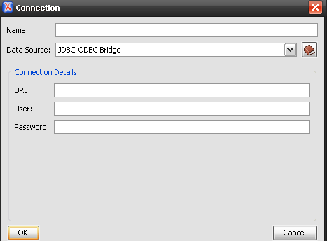

    - Give connection name as “ML-PROCESSOR”.
    - Select data source “MarkLogic-Conn”.
    - Give Port no. of XDBC as “7777”.
    - Userid and password as “admin”.
    - Webdav URL as “http://localhost:7779”
    - Click on Apply and then ok.

